Lab-10 Report
MOD-8 & MOD-6 Asynchronous Up-Counters

MIRIYALA PRANAY KAMAL
200030033
Aim of the experiment:
- Design and implement a mod-8 asynchronous up counter. Clearly indicate the minimum number of JK Flip-flops required (if any) and NAND gates required (if any).
- Design and implement a mod-6 asynchronous up counter. Clearly indicate the minimum number of JK Flip-flops required (if any) and NAND gates required (if any).

Components used:
- SN7476 - DUAL J-K FLIP-FLOPS WITH PRESET AND CLEAR
- IC-7400 - NAND gate
- Power supply
- Breadboard
- 1k resistor arrays (X2)
- LED display

Design Procedure & Circuit diagram:

For mod-8 asynchronous up-counter, the design procedure requires 3 JK flip-flops connected in series with the output Q given as clock signal to the next flip-flop and Q as output from each of the flip-flops.

This implementation using JK flip-flops is given as,

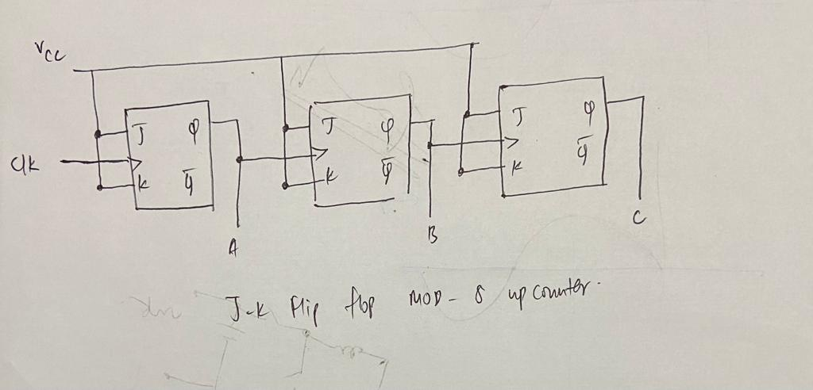

Similarly, for mod-6 asynchronous up-counter, the design procedure requires 3 JK flip-flops connected in series with the output Q given as clock signal to the next flip-flop and Q as output from each of the flip-flops and also by seeing the truth table we can find the following inference

We use IC 7400(NAND gate), for converting the initial Mod 8 design to Mod 6 design.

Logic design for Mod – 8 Asynchronous counter is

Output₁ | Output₂ | Output₃ | Decimal number
0 | 0 | 0 | 0
0 | 0 | 1 | 1
0 | 1 | 0 | 2
0 | 1 | 1 | 3
1 | 0 | 0 | 4
1 | 0 | 1 | 5
1 | 1 | 0 | 6
1 | 1 | 1 | 7

For Output₁ = 1 and Output₂ = 1, we get decimal representation as 6,7. To remove this, set clear variables of each JK flip flop to the output of the NAND gate, with inputs as Output₁ & Output₂.

Snapshots of circuit:
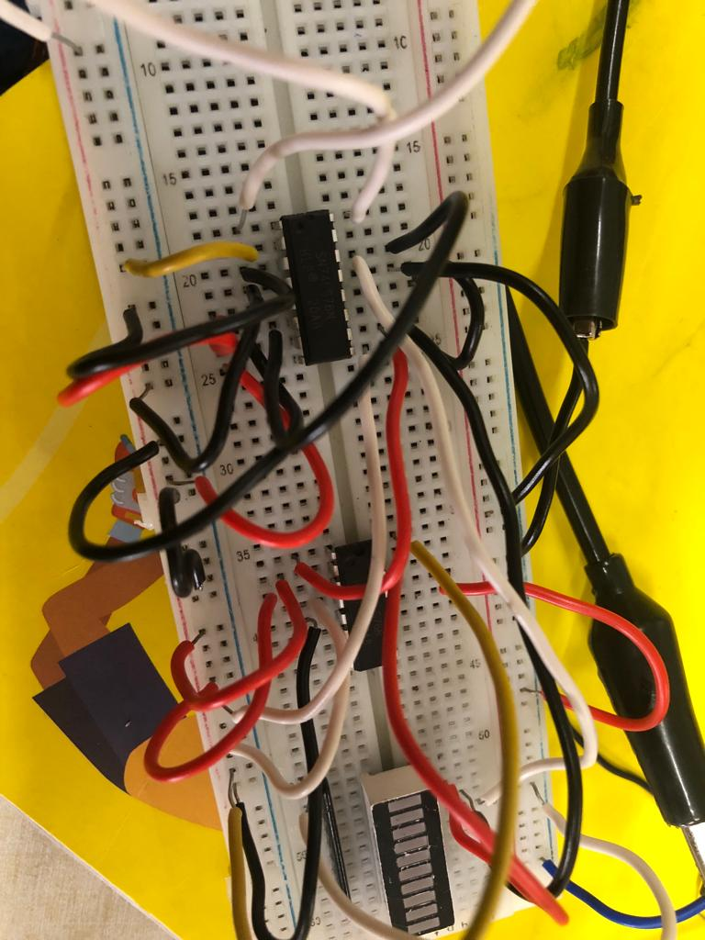
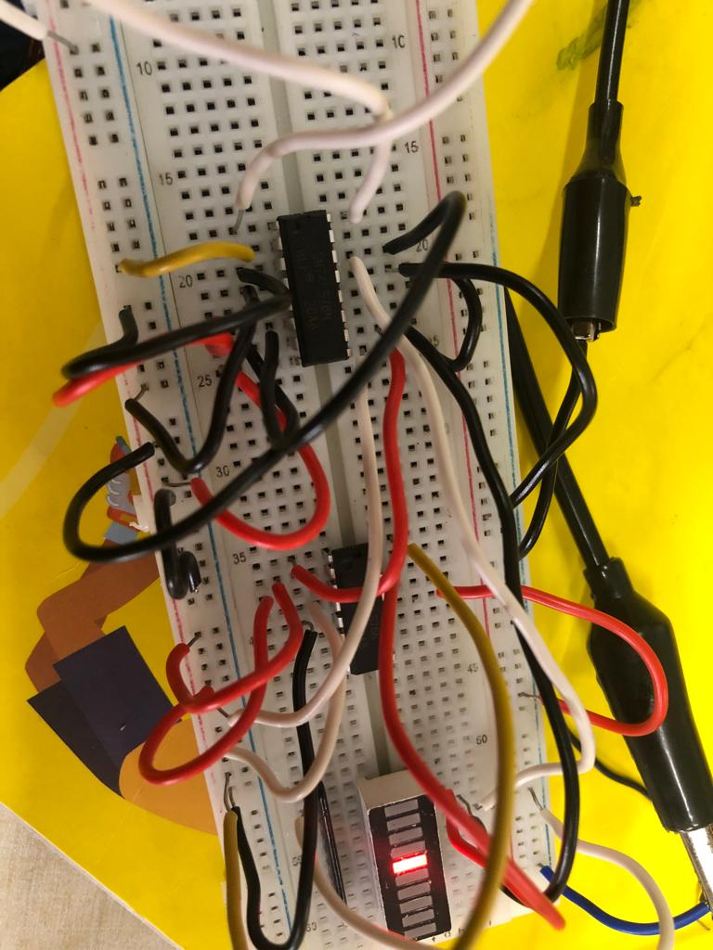
MOD-8 ASYNCHRONOUS COUNTER

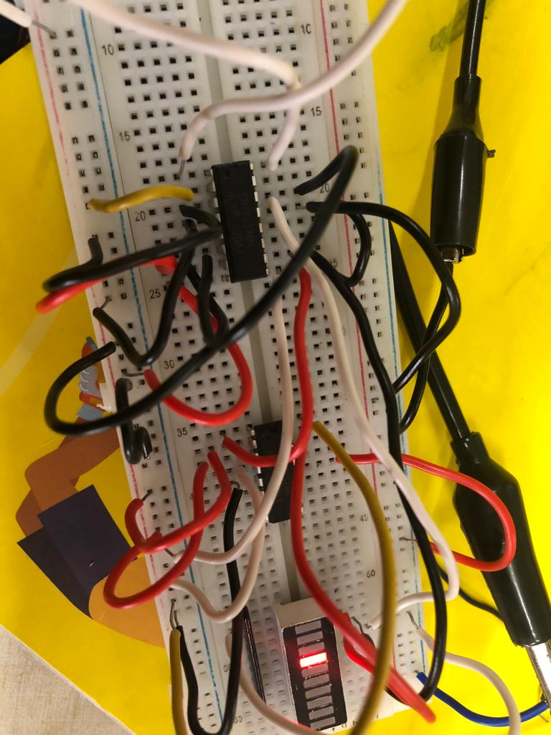
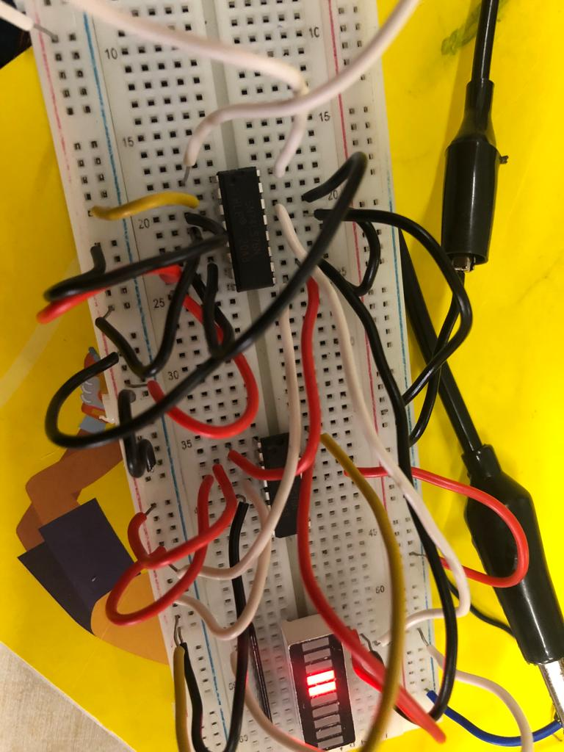

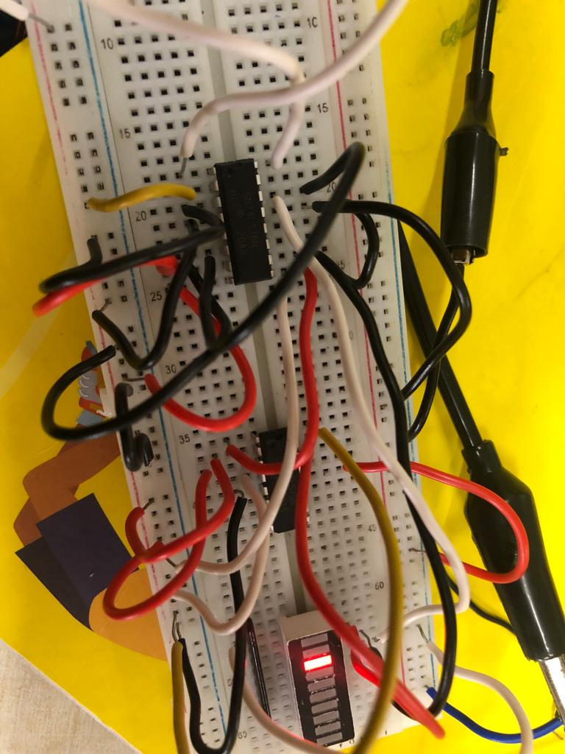
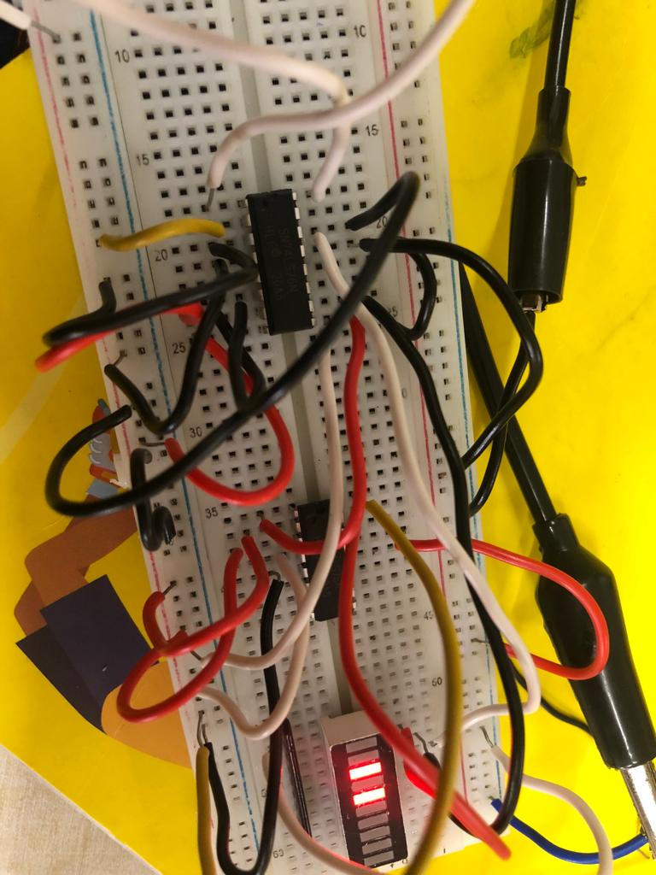

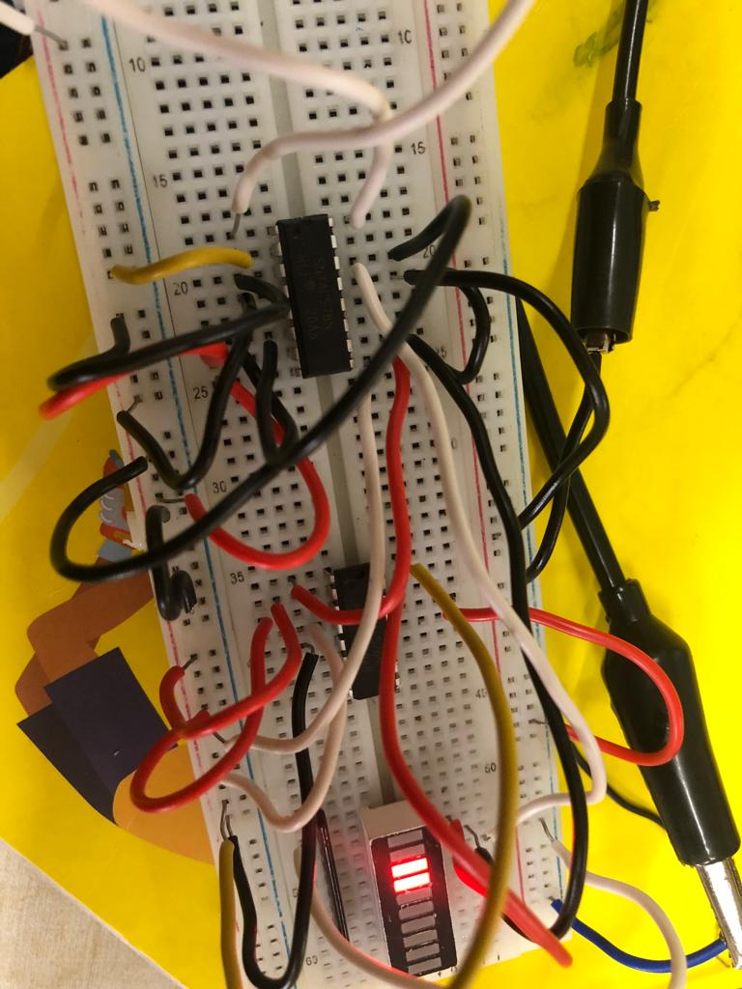
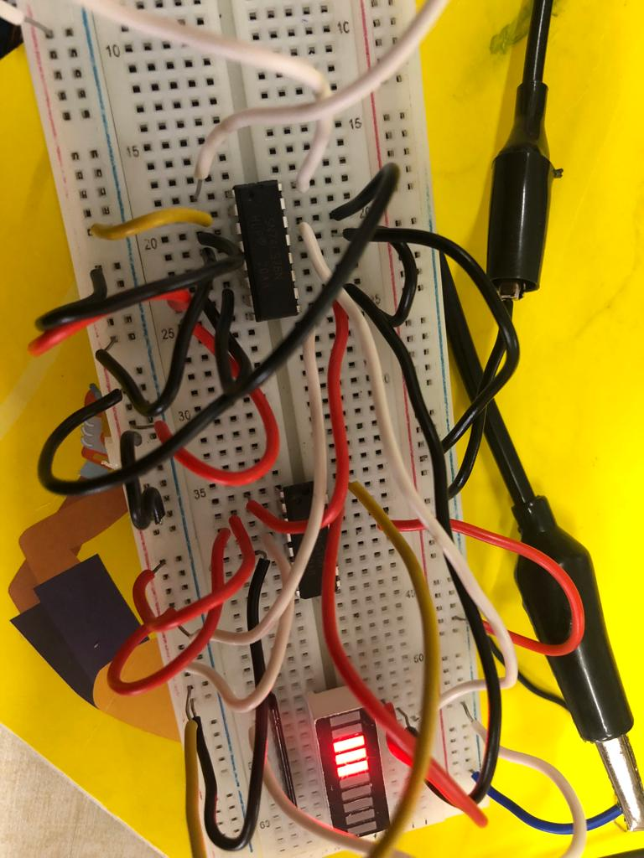

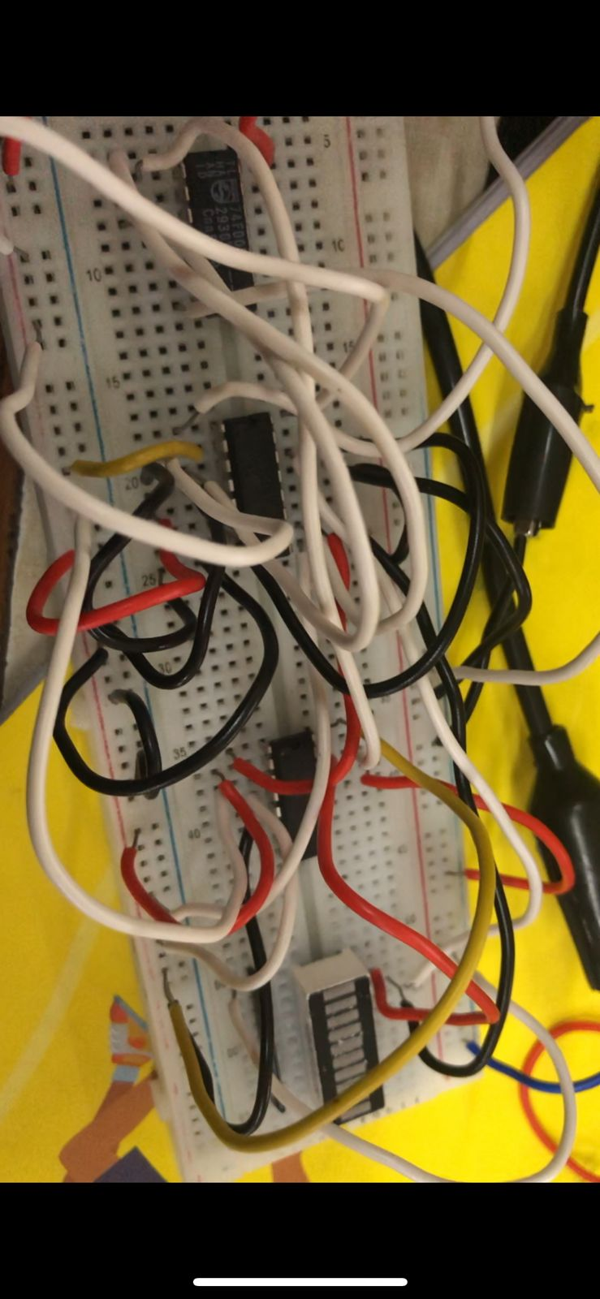
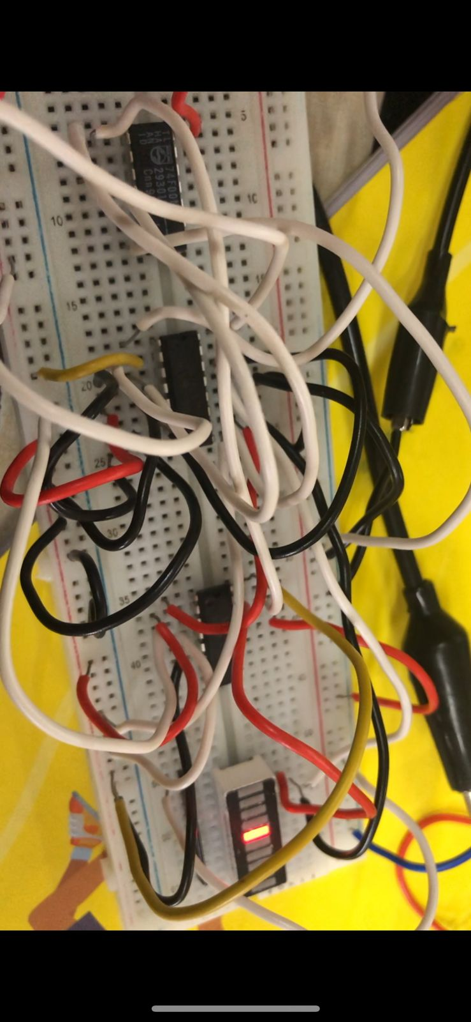

MOD-6 ASYNCHRONOUS COUNTER

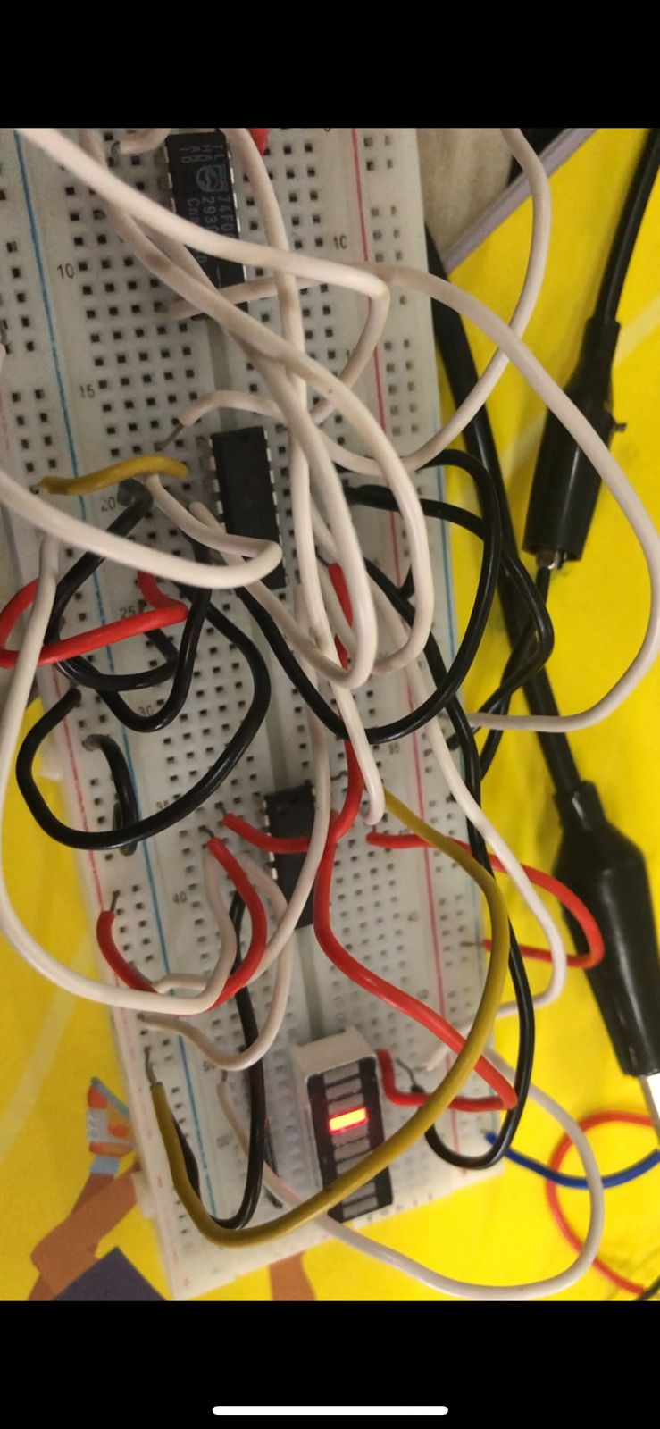
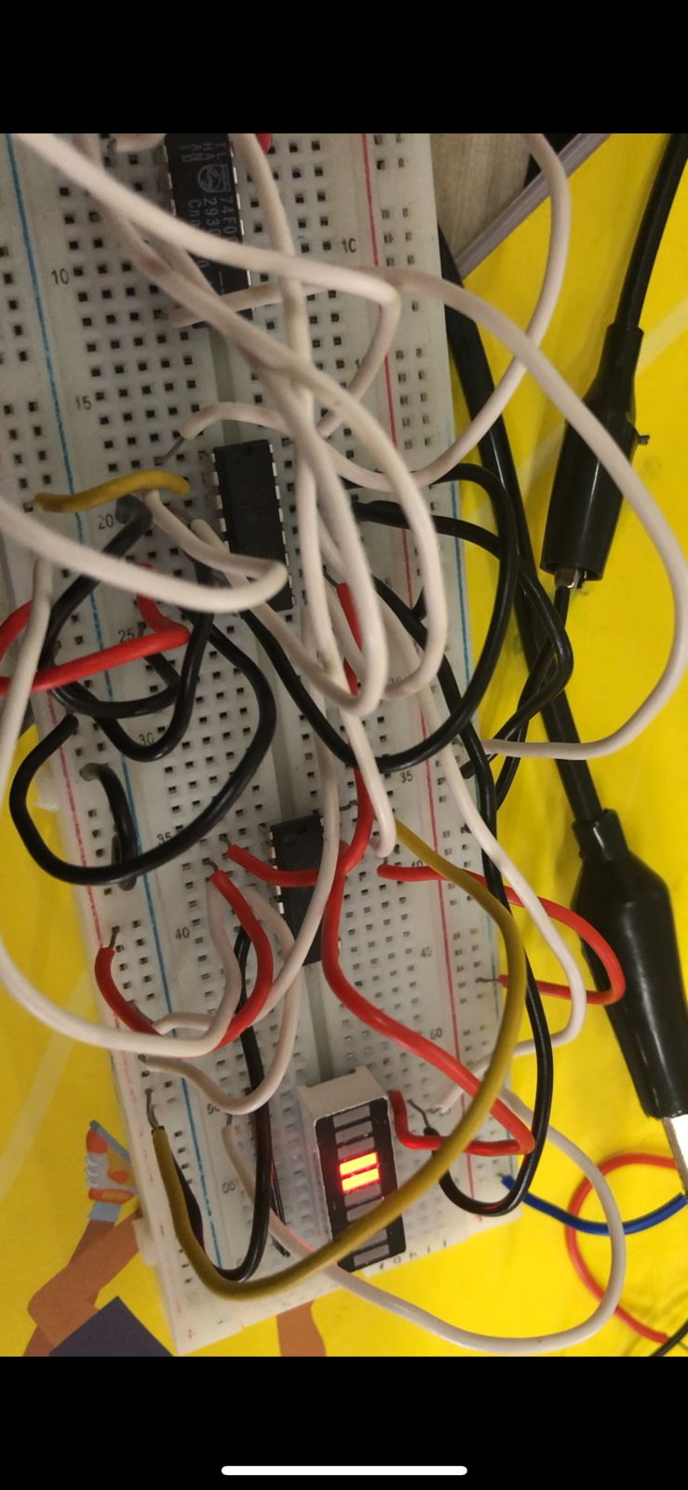

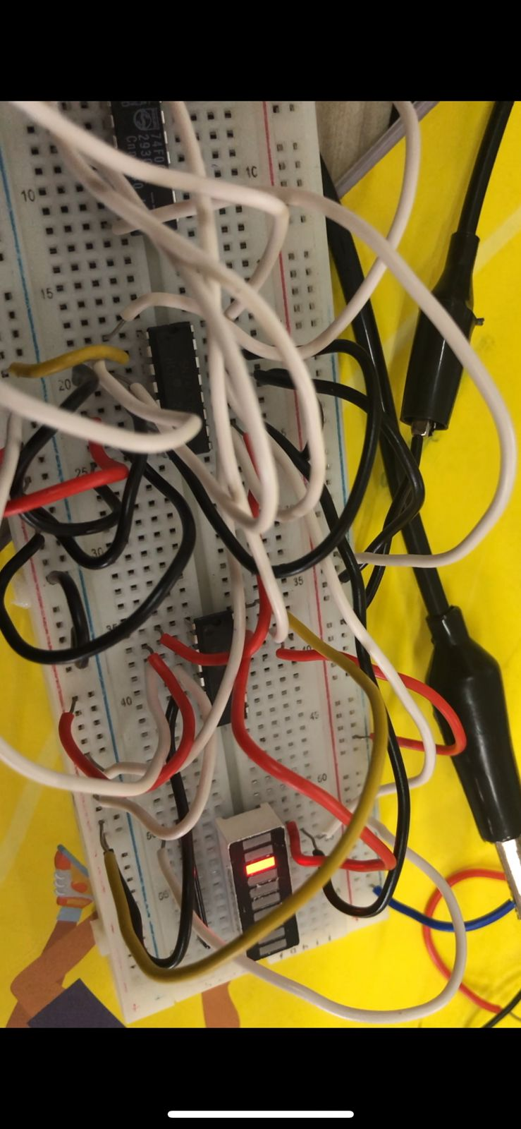
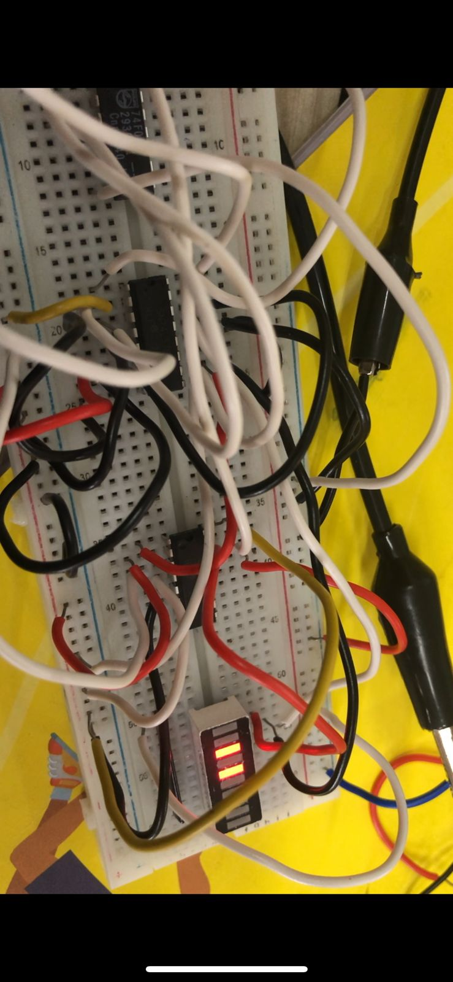

Results and Discussion:

In this experiment, we explored the design procedures of asynchronous counters given the specifications/state-transition diagram and implemented the same on the breadboard using Digital J-K Flip-flop ICs. We observed the outputs via LED arrays and the states of LEDs (on/off) change every 1 second as the clock frequency is 1 Hz Arbitrary function generator (AFG) in asynchronous counters, as all flip-flips don’t share a common clock, we can’t exactly say the time-gap between successive states change in LEDs because of delays in the circuital elements.

We also used the transition/ logic diagram to convert Mod-8 counter to Mod-6 counter using NAND iC’s.

